电子信息学院
实验报告书

课程名：《WEB系统开发》
题 目： 实验十四 SpringBoot&MyBatis
实验类别 【验证、设计、综合】
班 级： 软件2311
学 号： 251103530135
姓 名： 符淏

评语：

成绩： 指导教师： 郭煦

批阅时间： 2025年12月25日

- 实验内容或题目
SpringBoot 整合 MyBatis 开发WEB应用
2、实验目的与要求
（1） 熟练掌握SpringBoot项目的快速搭建与核心配置方式
（2） 理解SpringBoot整合MyBatis的核心原理与配置流程
（3） 掌握基于MyBatis实现数据库的CRUD（增删改查）操作
（4） 理解RESTful风格接口的设计规范，编写标准的后端接口
（5） 掌握接口测试方法（Postman/JUnit），验证数据库操作的正确性
（6） 理解SpringBoot中事务管理、参数校验、异常处理的应用实验步骤与源程序
实验步骤：
第4步：实体类代码
User:
package cn.edu.sdju.soft.exam14.entity;
import lombok.AllArgsConstructor;
import lombok.Data;
import lombok.NoArgsConstructor;
import java.time.LocalDateTime;
@Data
@AllArgsConstructor
@NoArgsConstructor
public class User {
Integer id;
String username;
String password;
Integer age;
String gender;
String email;
LocalDateTime createTime;
LocalDateTime updateTime;
}
UserDTO:
package cn.edu.sdju.soft.exam14.entity;
import lombok.AllArgsConstructor;
import lombok.Data;
import lombok.NoArgsConstructor;
@Data
@AllArgsConstructor
@NoArgsConstructor
public class UserDTO {
String username;
String password;
Integer age;
String gender;
String email;
}
第5步：Mapper接口代码
package cn.edu.sdju.soft.exam14.mapper;
import cn.edu.sdju.soft.exam14.entity.User;
import org.apache.ibatis.annotations.Mapper;
import java.util.List;
@Mapper
public interface UserMapper {
void addUser(User user);
User getUserById(Integer id);
List<User> selectAll();
void update(User user);
void deleteById(Integer id);
}
第6步：Mapper代码
<?xml version="1.0" encoding="UTF-8" ?>
<!DOCTYPE mapper
PUBLIC "-//mybatis.org//DTD Mapper 3.0//EN"
"http://mybatis.org/dtd/mybatis-3-mapper.dtd">
<mapper namespace="cn.edu.sdju.soft.exam14.mapper.UserMapper">
<!--新增用户-->
<insert id="addUser" parameterType="cn.edu.sdju.soft.exam14.entity.User" useGeneratedKeys="true" keyProperty="id">
insert into tb_user (username,password,age,gender,email,create_time,update_time)
values (#{username},#{password},#{age},#{gender},#{email},#{createTime},#{updateTime})
</insert>
<!-- 根据id查找用户 -->
<select id="getUserById" parameterType="java.lang.Integer" resultType="cn.edu.sdju.soft.exam14.entity.User">
SELECT id,username,password,age,gender,email,create_time,update_time
FROM tb_user
where id = #{id}
</select>
<!-- 查找所有用户 -->
<select id="selectAll" resultType="cn.edu.sdju.soft.exam14.entity.User">
SELECT id,username,password,age,gender,email,create_time,update_time
FROM tb_user
</select>
<!-- 更新用户信息 -->
<update id="update" parameterType="cn.edu.sdju.soft.exam14.entity.User">
UPDATE tb_user
<set>
<if test="username != null">username = #{username},</if>
<if test="password != null">password = #{password},</if>
<if test="email != null">email = #{email},</if>
<if test="age != null">age = #{age},</if>
<if test="gender != null">gender = #{gender},</if>
<if test="updateTime != null">update_time = #{updateTime},</if>
</set>
WHERE id = #{id}
</update>
<!-- 根据id删除用户 -->
<delete id="deleteById" parameterType="java.lang.Integer">
DELETE FROM tb_user
WHERE id = #{id}
</delete>
</mapper>
第7步：Service接口代码
package cn.edu.sdju.soft.exam14.service;
import cn.edu.sdju.soft.exam14.entity.User;
import cn.edu.sdju.soft.exam14.entity.UserDTO;
import java.util.List;
public interface UserService {
void addUser(UserDTO userDTO) throws Exception;
User getUser(Integer id) throws Exception;
List<User> getAllUser() throws Exception;
void updateUser(User user) throws Exception;
void deleteUser(Integer id) throws Exception;
}
第8步：Service实现类代码
package cn.edu.sdju.soft.exam14.service.impl;
import cn.edu.sdju.soft.exam14.entity.User;
import cn.edu.sdju.soft.exam14.entity.UserDTO;
import cn.edu.sdju.soft.exam14.mapper.UserMapper;
import cn.edu.sdju.soft.exam14.service.UserService;
import cn.edu.sdju.soft.exam14.utils.ValidationUtils;
import org.springframework.beans.factory.annotation.Autowired;
import org.springframework.stereotype.Service;
import org.springframework.transaction.annotation.Transactional;
import java.time.LocalDateTime;
import java.util.List;
@Service
public class UserServiceImpl implements UserService {
@Autowired
private UserMapper userMapper;
/**
* 添加用户业务逻辑
* @param userDTO
*/
@Override
@Transactional
public void addUser(UserDTO userDTO) throws Exception {
if(!ValidationUtils.isAgeValid(userDTO.getAge()) ||
!ValidationUtils.isEmailValid(userDTO.getEmail()) ||
!ValidationUtils.isUsernameValid(userDTO.getUsername())) {
throw new Exception("参数错误");
}
User user = new User();
user.setUsername(userDTO.getUsername());
user.setPassword(userDTO.getPassword());
user.setAge(userDTO.getAge());
user.setEmail(userDTO.getEmail());
user.setGender(userDTO.getGender());
LocalDateTime now = LocalDateTime.now();
user.setCreateTime(now);
user.setUpdateTime(now);
try {
userMapper.addUser(user);
} catch (Exception e) {
throw new Exception("数据库异常");
}
}
/**
* 根据id查询用户业务逻辑
* @param id
* @return
*/
@Override
public User getUser(Integer id) throws Exception {
try {
return userMapper.getUserById(id);
} catch (Exception e) {
throw new Exception("数据库异常");
}
}
/**
* 查询所有用户业务逻辑
* @return
*/
@Override
public List<User> getAllUser() throws Exception {
try {
return userMapper.selectAll();
} catch (Exception e) {
throw new Exception("数据库异常");
}
}
/**
* 更新用户信息业务逻辑
* @param user
*/
@Override
@Transactional
public void updateUser(User user) throws Exception {
if(user.getAge() != null && !ValidationUtils.isAgeValid(user.getAge()) ||
user.getEmail() != null && !ValidationUtils.isEmailValid(user.getEmail()) ||
user.getUsername() != null && !ValidationUtils.isUsernameValid(user.getUsername())) {
throw new Exception("参数错误");
}
user.setUpdateTime(LocalDateTime.now());
try {
userMapper.update(user);
} catch (Exception e) {
throw new Exception("数据库异常");
}
}
/**
* 删除用户业务逻辑
* @param id
*/
@Override
public void deleteUser(Integer id) throws Exception {
try {
userMapper.deleteById(id);
} catch (Exception e) {
throw new Exception("数据库异常");
}
}
}
第9步：控制器代码
package cn.edu.sdju.soft.exam14.controller;
import cn.edu.sdju.soft.exam14.entity.User;
import cn.edu.sdju.soft.exam14.entity.UserDTO;
import cn.edu.sdju.soft.exam14.service.UserService;
import lombok.extern.slf4j.Slf4j;
import org.apache.ibatis.annotations.Delete;
import org.springframework.beans.factory.annotation.Autowired;
import org.springframework.stereotype.Controller;
import org.springframework.web.bind.annotation.*;
import java.util.List;
@Slf4j
@RestController
@RequestMapping("/user")
public class UserController {
@Autowired
private UserService userService;
@PostMapping("/add")
public String addUser(@RequestBody UserDTO userDTO) throws Exception {
log.info("添加用户： " + userDTO.toString());
userService.addUser(userDTO);
return "success";
}
@GetMapping("/{id}")
public User getUser(@PathVariable Integer id) throws Exception {
log.info("查询id为: " + id + "的用户");
try {
return userService.getUser(id);
}catch (Exception e){
throw new Exception("接口调用失败");
}
}
@GetMapping("/list")
public List<User> getAllUser() throws Exception {
log.info("查询所有用户");
try {
return userService.getAllUser();
}catch (Exception e){
throw new Exception("接口调用失败");
}
}
@PutMapping("/update")
public void updateUser(@RequestBody User user) throws Exception {
log.info("更新用户信息: " + user.toString());
userService.updateUser(user);
}
@DeleteMapping("/{id}")
public String deleteUser(@PathVariable Integer id) throws Exception {
log.info("删除id为: " + id + "的用户");
try {
userService.deleteUser(id);
}catch (Exception e){
throw new Exception("接口调用失败");
}
return "success";
}
}

切面类UserAOP(用于实现日志打印和接口计时):
package cn.edu.sdju.soft.exam14.aop;
import lombok.extern.slf4j.Slf4j;
import org.aspectj.lang.JoinPoint;
import org.aspectj.lang.annotation.AfterReturning;
import org.aspectj.lang.annotation.Aspect;
import org.aspectj.lang.annotation.Before;
import org.aspectj.lang.annotation.Pointcut;
import org.springframework.stereotype.Component;
import org.springframework.web.bind.annotation.RequestBody;
import org.springframework.web.context.request.RequestContextHolder;
import org.springframework.web.context.request.ServletRequestAttributes;
import javax.servlet.http.HttpServletRequest;
import java.util.Arrays;
import java.util.Map;
@Slf4j
@Aspect
@Component
public class UserAOP {
String requestURL;
String parameterMapString;
long startTime;
@Pointcut("execution(* cn.edu.sdju.soft.exam14.controller.*.*(..))")
void aPoint() {}
@Before("aPoint()")
void takeOffCloth(JoinPoint jPoint) {
ServletRequestAttributes attributes = (ServletRequestAttributes) RequestContextHolder.getRequestAttributes();
if (attributes != null) {
HttpServletRequest request = attributes.getRequest();
requestURL = request.getRequestURL().toString();
Map<String, String[]> parameterMap = request.getParameterMap();
Object[] args = jPoint.getArgs();
parameterMapString = Arrays.toString(args);
startTime = System.currentTimeMillis();
}
}
@AfterReturning(value = "aPoint()", returning = "result")
void putOnCloth(JoinPoint jPoint, Object result) {
long consume = System.currentTimeMillis() - startTime;
log.info("请求路径为: " + requestURL + " 请求参数为: " + parameterMapString + " 响应结果为: " + result + " 耗时: " + consume + " ms");
}
}

全局异常处理器：
package cn.edu.sdju.soft.exam14.handler;
import lombok.extern.slf4j.Slf4j;
import org.springframework.http.HttpStatus;
import org.springframework.http.ResponseEntity;
import org.springframework.web.bind.annotation.ExceptionHandler;
import org.springframework.web.bind.annotation.RestControllerAdvice;
import java.util.HashMap;
import java.util.Map;
@RestControllerAdvice
@Slf4j
public class GlobalExceptionHandler {
@ExceptionHandler
public ResponseEntity<Map<String, Object>> exceptionHandler(Exception ex){
log.error("异常信息：{}", ex.getMessage());
Map<String, Object> result = new HashMap<>();
result.put("code", HttpStatus.INTERNAL_SERVER_ERROR.value());
result.put("message", ex.getMessage());
result.put("data", null);
result.put("timestamp", System.currentTimeMillis());
return ResponseEntity.status(HttpStatus.INTERNAL_SERVER_ERROR).body(result);
}
}

- 测试数据与实验结果（可以抓图粘贴）
新增用户：
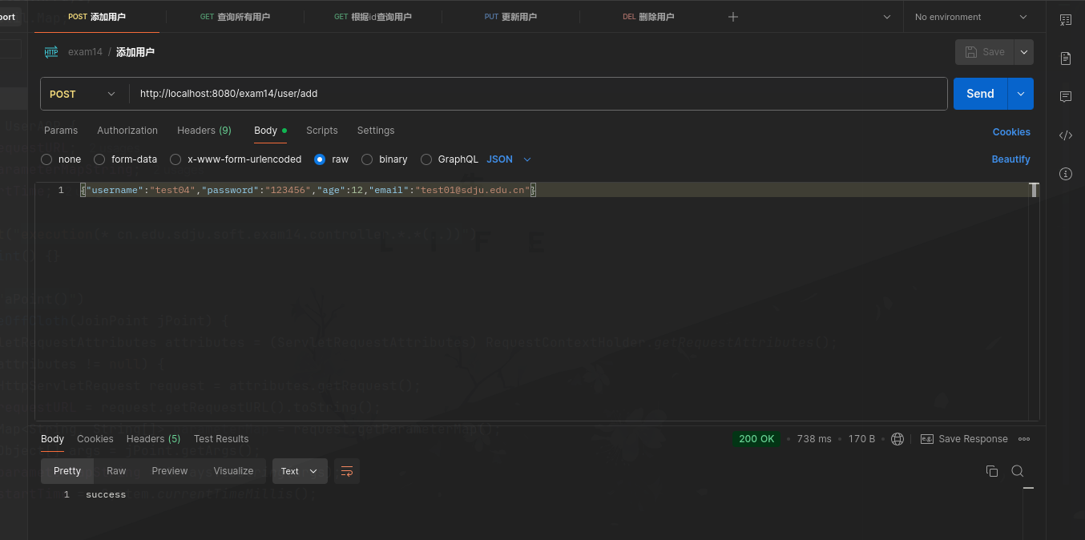
控制台日志输出与计时：
发送增加用户请求之后的数据库结果：
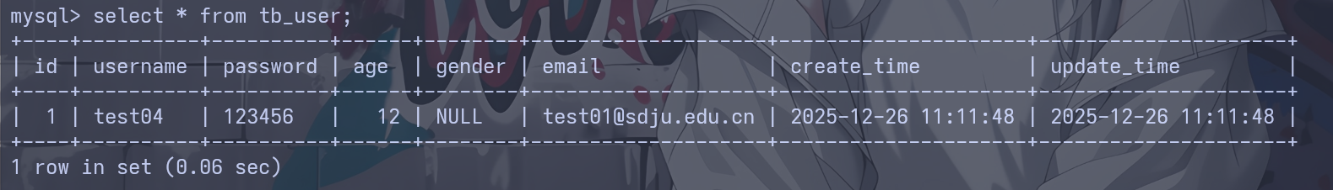
测试全局异常处理器，手动输出超过120的年龄：
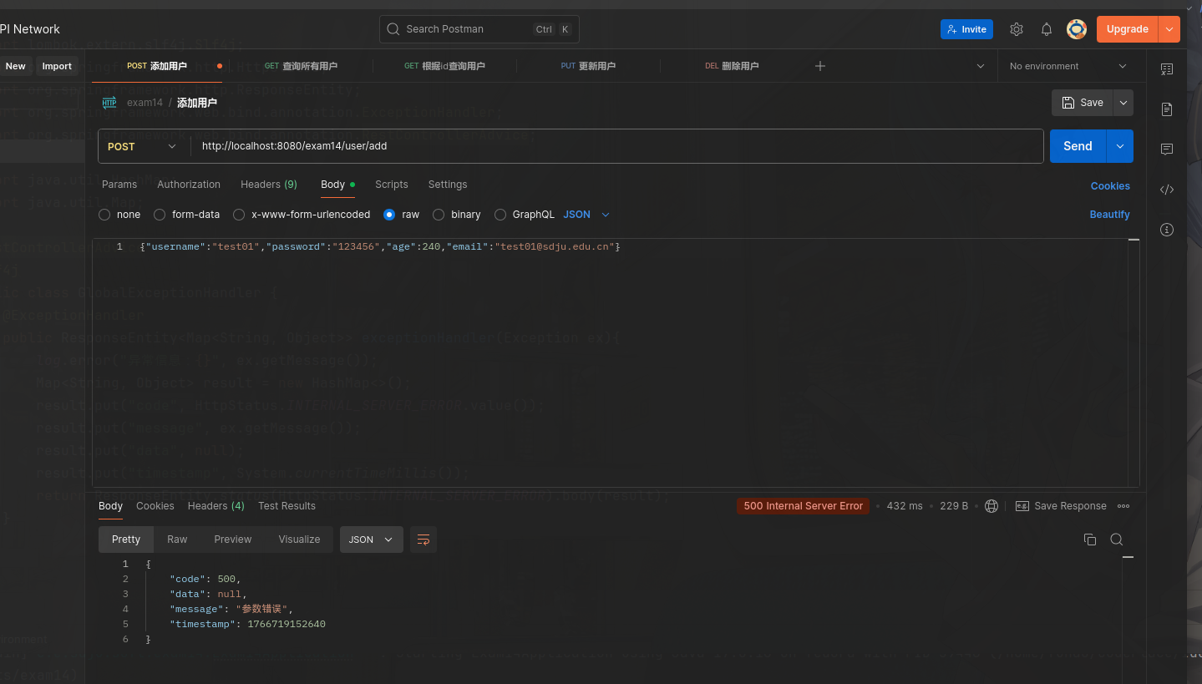
日志输出：
- 结果分析与实验体会
通过这次实验，我已经掌握使用springboot开发接口，并运用全局异常拦截器捕获异常情况，并使用AOP实现日志输出和程序计时。

